SOFT8026 - Data-driven Microservices
Assignment 1 Form

Instructions
Please complete the following form and include in the zip file you submit. Include screenshots / images in the appendices below the form.

Discussion of Architecture
Put a diagram of your architecture opposite (e.g. paste an image); indicate the microservices, integration endpoints, messages being sent, etc. | 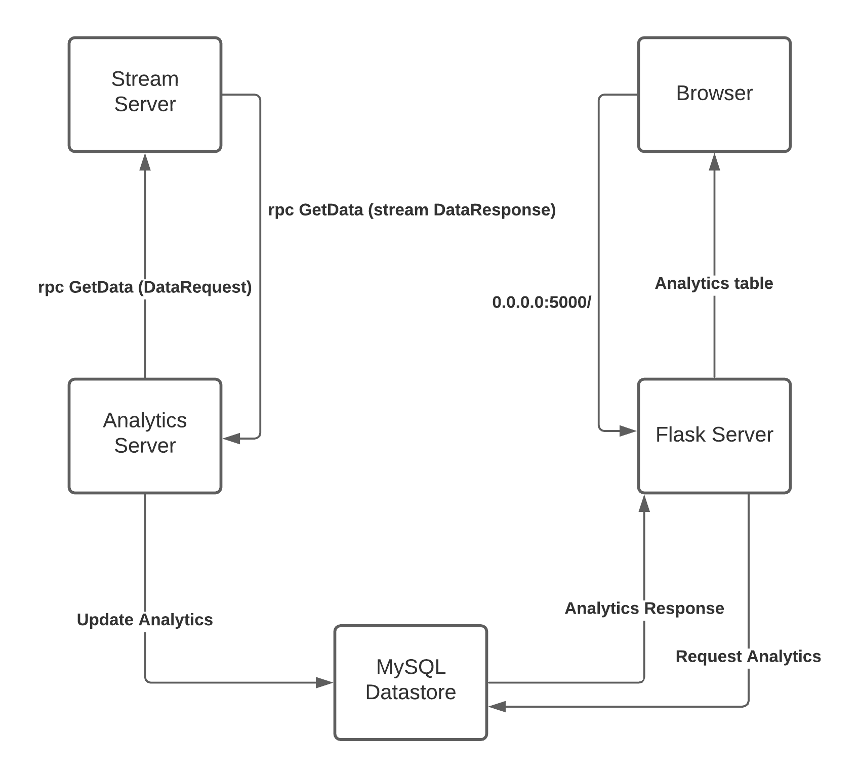  Once the microservices start, Analytics server sends a rpc request to Stream server. Stream server responds by streaming the csv file using the yield keyword. The analytics Server starts looping over the yielded responses calculating the new analytic metrics. At the end of the calculations per yielded row, the analytics server updates the mysql datastore with the current up to date results for the 4 metrics. The flask server will only fetch the latest up to date metrics from the mysql datastore as part of a responce from the browser request at 0.0.0.0:5000/  The three minute average is calculated based on timestamps inside the analytics server, once the container starts the first timestamp is created as a base point.  In the streamServer after every second row yielded, its paused for 1-4 seconds via time.sleep(random.randint(1, 5))  The MySql schema is shown below in the Appendix section
Why did you opt for the microservices you did? You could address topics from the lectures, e.g. bounded contexts, independent pipelines, etc. | The reason why I opted for the MySQL datastore approach is because I prefered saving the metrics rather than sending them as a redis log. Furthermore since we covered basics of redis in our labs I wanted to figure out how a containerised datastore works as it’ll be benificial for future work.  Furthermore the datastore I believe is a better implementation that sending the metrics back to the stream server via rpc which then sends them to the flask server which was my inital architecture. The datastore allows for loose coupling between the microservices so that only minimal communication between them is required. The downside to using a datastore is that is the sql schema is upated both the analytics and flask server must be updated  Each microservice has an independant pipeline which is defined in their own dockerfile used by the DockerCompose.yml file. The only exception to this is the MySQL datastore which does not have its own dockerfile as I’m not building its container per-say. Instead I’m using a prebuilt container from docker-hub available from https://hub.docker.com/_/mysql  There are three bounded contexts in this application, the Stream server which solely handles receieving/responding rpc requests and yielding data from a pandas dataframe derived from csv file  The analytics server which sends rpc requests, calculates metrics and then updates datastore to reflect metrics  The flask server which simply fetches data from datastore and returns it  the MySQL datastore acts as a shared model between the Analytics server and the flask server  Also in the dockerCompose file, ports are exposed such as flask port 5000 and mysql port 3306 so outside sources can connect and use the system. For instance port 5000 in flask is exposed so my broser can make requests to it. Port 3306 is exposed in MySQL as it allows me to view the current metrics in mySql Workbench to validate the calculations
Checklist of requirements completed | Delete as appropriate
Do you have a Dockerfile per microservice that you have created? | YES, besides the mysql microservice as thats pulled from docker hub in the dockerCompose.yml file
Do you have a gRPC proto file with a service, rpcs and messages for each microservice? | No, I have the proto file with service/rpcs for the stream server and the analylitics server. For communicating between analylitics server and flask server mysql datastore is used as it’s medium
Do you have your Dockerfiles and other microservice files (python scripts, requirements.txt, etc) in separate folders? | Yes
Do you have a functioning Docker Compose file? | Yes
Are you streaming data, simulating real-time throughout? | Yes
Do you have 4 pieces of analytics calculated, including a window-on-data (e.g. rolling 3-minute window)? | Yes
Are you displaying live analytics on a web page? | Partially, web page has to be refreshed manually to get up to date analytics
Any other comments, e.g. anything you want to highlight that could otherwise be missed by the marker? | I have another directory called data which holds init.sql which sets up the initial database for the mysql datastore created in the dockerCompose file  the 4 metrics being calculated:  1) aggregate metric – average number of words per post  2) rolling 3 minute metric – average word length  3) post with some criteria – most words  4) metric not based on post title – author with most deleted posts  Also as you requested I’m not including the csv file as part of the final submission, when testing put the r_dataisbeautiful_posts.csv in the base directory of streamServer  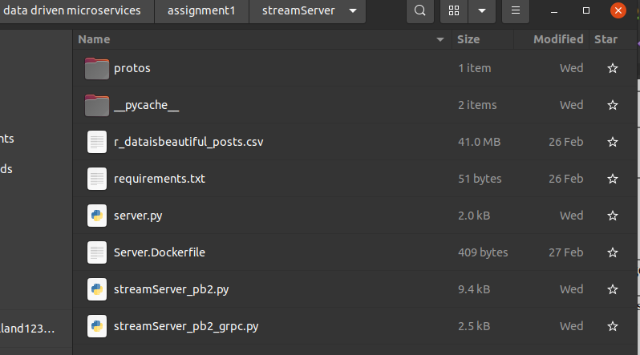

Appendix – Screenshot(s) of your application running (e.g. Log output as it starts up, any log output as it runs, any web pages, etc.)

Docker compose running logs:

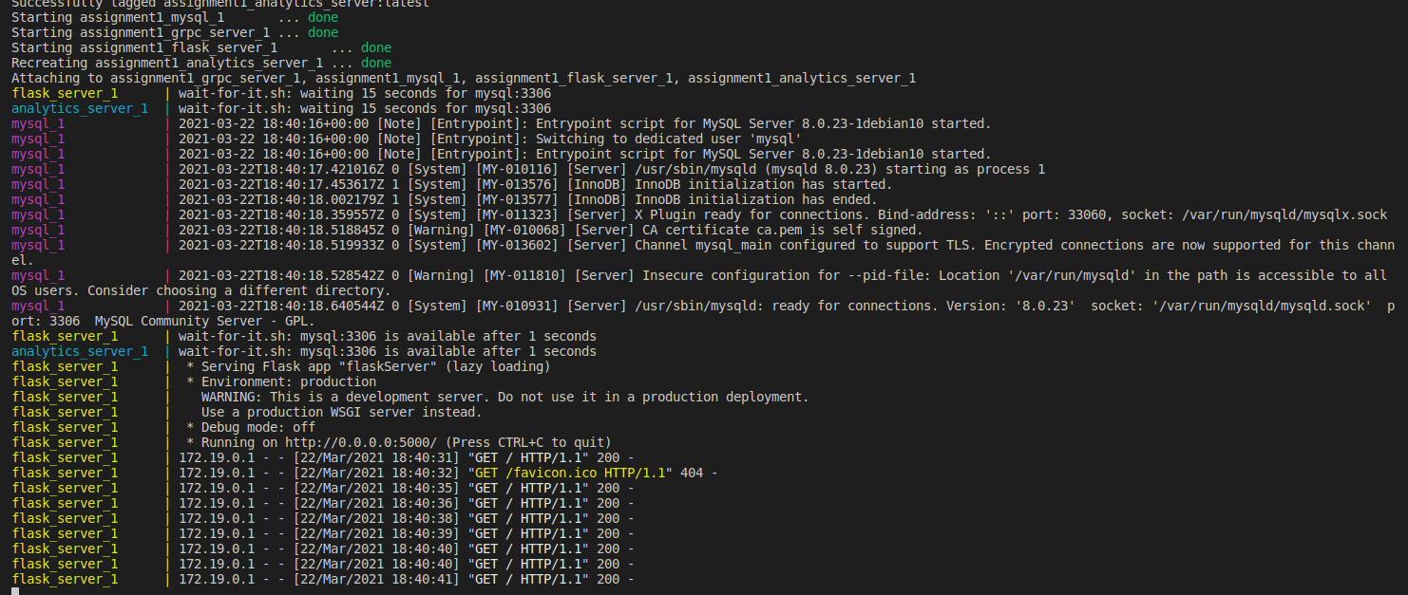

Flask table:

Build grpc/stream server:

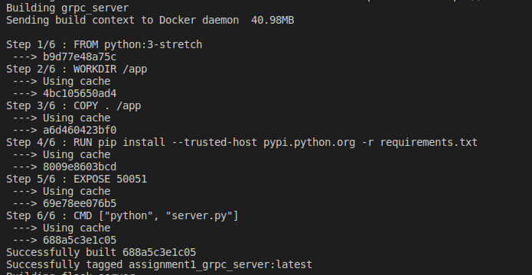

Build Flask:
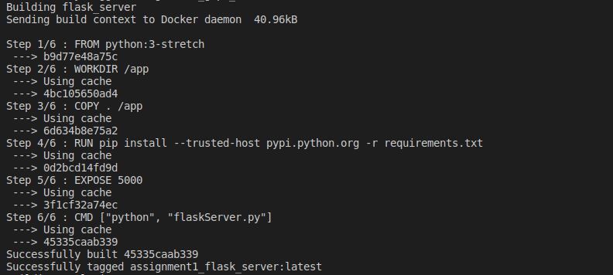

Build Analytics Server:

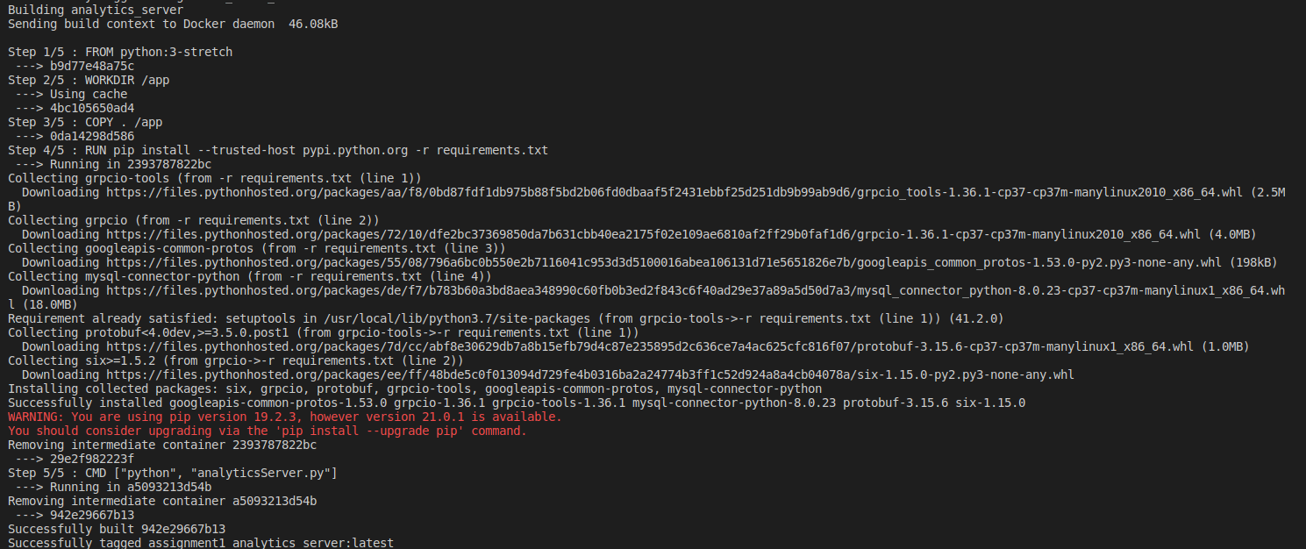

init.sql file:

